**EXPERIMENT NO : 6**

# Aim:Calculate the Effort, Scheduled time for development by considering developer having high application experience and very low experience in programming by using Intermediate COCOMO

**Explanation: The Intermediate COCOMO**

The intermediate model estimates software development effort in terms of size of the program and other related cost drivers parameters (product parameter, hardware parameter, resource parameter, and project parameter) of the project. The estimated effort and scheduled time are given by the relationship:

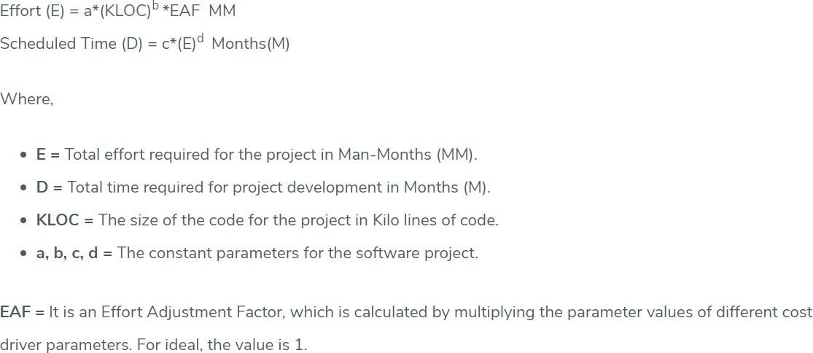

COST DRIVERS PARAM ETERS VERY

LOW

LOW N O MINAL H IG H VERY

HIGH

Product Pa*ra*meter

Required Softwa re Size of Project Database

Com pIexity of The Project

0.75 O.88

O. D 4

085

1 lo

1 O8

1.1

1.d

1. 1 C



Hardware Parameter

Performance Restricti on

Memory Restriction

virtu aI Machine Environment

Required Turn a bout Time

  



087

O94

Personnel Para meter

1. 1 1

1.OC

1.15





1. 2 1

1.3



|  |  |  |  |  |  |
| --- | --- | --- | --- | --- | --- |
| Analysis Capa biI '*Y | 146 | 1.19 | 1 | 0.86 | O. 7 1 |
| Ap pl ication Experience | 1. 29 | 1 13 |  | 051 | 082 |
| S oftwa re En g ineer Ca pa bi lity | 1.42 | 1.17 |  | 086 | 07 |
| Virtua I Machine Experience | 121 | 1 1 |  |  | NA |
| Programming Experience | 1.14 | 107 |  | 005 | N A |
| Project Parameter | | | | | |
| Softwa re Engineering Method s | 1.24 | 1.1 |  | 001 | 0.82 |
| Use of Softwa re Tool s | 1 24 | 1 1 |  | 0Al | O83 |
| Development Time | 1 23 | 108 |  | lO4 |  |

Example: For a given project was estimated with a size of 300 KLOC. Calculate the Effort, Scheduled time for development by considering developer having high application experience and very low experience in programming.

Given the estimated size of the project is: 300 KLOC

Developer having highly application experience: 0.82 (as per above table)

Developer having very low experience in programming: 1.14(as per above table) EAF = 0.82*1.14 = 0.9348

Effort (E) = a*(KLOC)b *EAF = 3.0*(300)1.12 *0.9348 = 1668.07 MM

Scheduled Time (D) = c*(E)d = 2.5*(1668.07)0.35 = 33.55 Months(M)